
E-13, UPSIDC Site-IV, Kasna Road, Greater Noida - 201308, India
Phone: +91.120.4296878 | Website: www.khuranaandkhurana.com www.iiprd.com
Email: info@khuranaandkhuraana.com | iiprd@iiprd.com
Indian Offices: Noida | New Delhi | Bangalore | Mumbai | Pune | Mumbai | Hyderabad | Jalandhar | Chennai
International Offices: US |Bangladesh | Sri Lanka | Malaysia | Vietnam | Myanmar | Nepal | Malaysia

INVENTIVE DISCLOSURE - CONFIDENTIAL

- Proposed Title of the Invention Emergency Sos vehicle

- Proposed Abstract of the Invention (Kindly explain the crux of the invention in about 150 to 200 words.)

The proposed 6x6 autonomous terrain vehicle (ATV) rover is poised to revolutionize emergency response and surveillance operations. This cutting-edge vehicle boasts self-driving capabilities, harnessing solar power to ensure uninterrupted operation even in the most remote locations. Additionally, it features a designated area for drones, enabling them to conduct a variety of tasks efficiently. Equipped with a high-resolution camera for comprehensive monitoring and an ECG sensor to track individual’s health status during crises such as natural disasters, the rover is a versatile tool for emergency situations. Its advanced functionalities include ground penetrating radars and acoustic systems, facilitating the detection and rescue of individuals trapped underground post-earthquakes.
The rover’s integrated drone is outfitted with a thermal camera which enhancing visibility in challenging environments. In water related emergencies, the rover can autonomously deploy life jackets to aid in life -saving efforts. Furthermore, it is capable of autonomously navigating obstacles and delivering essentials supplies to those in distress. Our primary objective with the development of this rover is to enhance the speed, safety and effectiveness of emergency responses, surpassing the limitations of conventional technologies.

- Key Words:

- Autonomous Terrain Vehicle (ATV)
- Search and Rescue Robot
- Surveillance Drone.
- Emergency Response Robot
- Healthcare Robotics

- Background of the Invention:

What are the present technologies that exist in the field of your invention and what are the limitations of the same? (Present state of Art)

Present technologies in the field of drones for rescue operations include advanced features such as thermal imaging cameras, high-resolution cameras, GPS tracking systems, obstacle avoidance sensors, and payload delivery capabilities. These technologies enable drones to locate and assist individuals in distress, provide real-time aerial surveillance of disaster areas, and deliver essential supplies to inaccessible locations.
However, some limitations of current drone technologies for rescue operations include limited flight time and range, susceptibility to adverse weather conditions, restricted payload capacity, and challenges in navigating complex environments with obstacles. Additionally, issues related to regulatory restrictions, privacy concerns, and communication interference can hinder the effective deployment of drones in rescue missions.
Despite these limitations, ongoing research and development efforts are focused on enhancing drone capabilities for rescue operations, addressing challenges such as extended flight endurance, improved obstacle avoidance systems, and enhanced communication protocols. By overcoming these limitations, drones have the potential to significantly improve the efficiency and effectiveness of rescue operations in various emergency scenarios.

- What problems does the invention address and how your Invention is able to overcome the limitations/ problems of the existing technologies?

- Navigating Tough Terrain:
Problem: In emergency situations, rescue efforts are often hindered by difficult terrain. Debris from natural disasters, collapsed structures, or uneven landscapes can make it challenging for traditional vehicles and even specialized robots to access critical areas. This delay in reaching victims can be life-threatening.
Solution: Your rover's innovative design incorporates a 6-wheel drive system specifically engineered for all-terrain navigation. The wheels likely feature robust treads and independent suspension, allowing the rover to maintain traction and stability on various surfaces. This could include climbing over small obstacles, traversing loose soil or rubble, and even fording shallow water. The rover's low center of gravity and possibly adjustable chassis height enable it to navigate under fallen structures or through narrow passages. By reaching areas inaccessible to larger vehicles or humans, the rover significantly expands the range of rescue operations and reduces response times.

- Versatility and Functionality:
Problem: Many existing rescue robots are designed for specific tasks, limiting their usefulness across different emergency scenarios. This specialization often means multiple devices are needed, increasing complexity, cost, and logistical challenges during critical operations.
Solution: Our multi-function rover serves as a versatile platform for various rescue tasks. The inclusion of a drone pad allows for aerial reconnaissance and potentially small payload delivery to hard-to-reach locations. Onboard medical sensors can perform initial triage on victims, providing vital information to rescue teams before they arrive. The ability to deliver supplies means the rover can transport water, food, medical kits, or communication devices to survivors. This all-in-one approach maximizes efficiency, reducing the need for multiple specialized units and allowing rescue teams to adapt quickly to changing situations.

- Remote Control and Communication:
Problem: In disaster zones, communication infrastructure is often damaged or overwhelmed. This can limit the effectiveness of remote-controlled rescue devices and hinder coordination between rescue teams and command centers.
Solution: Our rover addresses this challenge through a dual approach. The Bluetooth remote control system , and the telemetry system allows for precise maneuvering in the immediate vicinity, crucial for navigating tight spaces or hazardous areas. The integrated smartphone serves as a robust communication link to emergency services. This could include video calls, data transmission, or even act as a mobile hotspot to extend communication range. By providing a reliable communication channel, the rover enhances situational awareness and allows for real-time decision-making, crucial in dynamic emergency environments.
- Reliable Power Supply:
Problem: Extended rescue operations often face power supply challenges. Batteries in rescue equipment can deplete quickly, especially when operating various systems simultaneously. Recharging or replacing batteries in the field is often impractical and can cause significant downtime.
Solution: The incorporation of solar-charged cells in your rover provides a sustainable and reliable power source. This system likely includes high-efficiency solar panels coupled with advanced battery technology for energy storage. The ability to recharge while operating means the rover can function continuously, even during prolonged missions. This self-sufficiency is particularly valuable in remote areas or prolonged disaster scenarios where external power sources may be unavailable. The system's ability to operate in low-light conditions suggests the use of highly sensitive photovoltaic cells or potentially supplementary charging methods.
- Enhanced Surveillance:
Problem: Gathering accurate, real-time information in disaster areas is crucial but often challenging. Ground-based observations can be limited by obstacles or dangerous conditions, while traditional aerial surveys may be too infrequent or lack the necessary detail.
Solution: Your rover's integrated drone pad and high-resolution cameras create a powerful surveillance system. The drone can provide rapid aerial assessments, mapping out the disaster area and identifying potential hazards or survivors from above. This bird's-eye view complements the rover's ground-level observations, creating a comprehensive picture of the emergency scene. The high-resolution cameras, likely equipped with zoom capabilities and possibly infrared or night vision, allow for detailed inspection of specific areas. This dual approach to surveillance aids in search and rescue efforts, damage assessment, and strategic planning for emergency response teams.
- Finding People Trapped Underground:
Problem: In scenarios involving collapsed structures or landslides, locating survivors trapped underground is a critical and time-sensitive challenge. Traditional methods like acoustic listening or search dogs can be slow and may miss deeply buried individuals.
Solution: Your rover employs advanced technology to address this issue. The ground-penetrating radar system can create detailed subsurface maps, identifying voids or anomalies that might indicate the presence of survivors. This technology can penetrate various materials and depths, providing a non-invasive way to "see" underground. Complementing this, the acoustic detection system is designed to pick up faint sounds like tapping or calls for help. By combining these technologies, the rover can quickly survey large areas and pinpoint potential locations of trapped individuals, dramatically reducing search times and increasing the chances of successful rescues.
- Identifying People in Low Visibility:
Problem: Many emergency situations involve conditions of poor visibility, such as smoke-filled environments, nighttime operations, or dense fog. These conditions severely hamper traditional visual search methods, potentially leaving survivors undetected.
Solution: The thermal camera equipped on your rover's drone addresses this challenge effectively. Thermal imaging detects heat signatures, allowing it to identify warm bodies against cooler backgrounds. This technology works regardless of lighting conditions or visual obstructions like smoke or light fog. The ability to quickly scan large areas from the air and detect human heat signatures significantly enhances the efficiency of search operations. It can help locate survivors who might be hidden from view, trapped in structures, or lost in expansive areas, providing rescue teams with precise locations for their efforts.
By combining these solutions, we designed our rescue rover represents a significant advancement in emergency response technology. Its ability to navigate in difficult terrain, perform multiple functions, maintain communication, operate continuously, provide comprehensive surveillance, locate underground survivors, and identify people in low visibility conditions makes it an invaluable tool for rescue operations. The integration of these features into a single, versatile platform addresses many of the key challenges faced in complex emergency scenarios, potentially saving lives and improving the overall effectiveness of rescue efforts.

- Detailed Explanation of the Invention along with working examples. Kindly provide an elaborated description of each and every aspect of the invention (product and/or process) in great detail.

Our 6x6 ATV rover is a game-changer in emergency response and rescue operations, specifically designed to support teams like the National Disaster Response Force (NDRF) in the most challenging environments. This all-terrain vehicle serves as a mobile command center, search and rescue platform.
The rover's 6-wheel drive system is built to tackle the toughest terrains encountered in disaster zones. Each wheel has independent suspension and is powered separately, allowing the rover to navigate through debris, climb over obstacles, and even wade through shallow water. This means our rover can reach victims in areas inaccessible to traditional vehicles, crucial in scenarios like earthquake-damaged urban areas or flood-affected regions.
Advanced Search and Rescue Capabilities: Equipped with state-of-the-art technology, our rover significantly enhances search and rescue efforts:
- Thermal Imaging: A high-resolution thermal camera helps locate survivors by detecting body heat, even through smoke or in darkness.
- Ground-Penetrating Radar: This technology can detect voids or anomalies beneath rubble, helping locate survivors trapped underground.
- Acoustic Sensors: Highly sensitive microphones can pick up faint sounds like tapping or calls for help, guiding rescuers to trapped individuals.
- Drone Integration: A deployable drone provides aerial surveillance, expanding the search area and offering a bird's-eye view of the disaster zone.

7.Medical Unit: Our rover isn't just about finding survivors – it's equipped to provide immediate medical assistance:
- Telemedicine Suite: High-definition cameras and a secure communication system allow remote doctors to assess patients and guide on-site responders.
- Portable Medical Equipment: The rover carries essential medical devices like defibrillators, oxygen concentrators, and vital signs monitors.
- Medical Supply Storage: Climate-controlled compartments store medications, IV fluids, and other critical supplies, ensuring they remain viable even in extreme conditions.
- Deployable Shelter: A quick-setup medical tent can be deployed from the rover, creating a sterile environment for emergency procedures.
Autonomous Navigation and Remote Operation: In hazardous environments, the rover can operate autonomously or be controlled remotely:
- LiDAR and AI-powered navigation allow the rover to plot the safest, most efficient path through debris-filled areas
- Remote control capabilities enable NDRF operators to maneuver the rover from a safe distance when human presence is too risky.
Communication Hub: In disaster zones where infrastructure is damaged, our rover becomes a crucial communication link:
- Satellite Uplink: Ensures connection with command centers and medical experts, even when local networks are down.
- Mobile Signal Booster: Extends cellular coverage in affected areas, helping both rescuers and survivors maintain communication.
Power and Endurance:
- Solar Charging: High-efficiency panels allow for extended operation in remote areas.
- Battery System: Advanced lithium-polymer batteries provide up to 72 hours of continuous operation.
- Backup Generator: For extended missions, a compact, fuel-efficient generator ensures the rover can keep operating.
Customizable for Specific Missions: The rover's modular design allows NDRF teams to customize it for different scenarios:
- Flood Rescue Configuration: Includes inflatable rafts and water rescue equipment.
- Earthquake Response Setup: Focuses on heavy lifting equipment and structural assessment tools.
- Mass Casualty Incident Mode: Maximizes space for medical supplies and triage capabilities.
Real-World Applications:
- Urban Search and Rescue: Navigating through collapsed buildings and providing immediate medical care to trapped survivors.
- Remote Area Emergencies: Serving as a mobile medical unit in hard-to-reach disaster zones.
- Mass Casualty Triage: Quickly assessing and categorizing multiple victims in large-scale disasters.
Conclusion:
Our 6x6 ATV rover represents a significant advancement in emergency response technology. By combining robust all-terrain capabilities with advanced medical and search-and-rescue features, it serves as an invaluable tool for NDRF and similar organizations. This rover doesn't just aid in finding and reaching survivors – it brings the capabilities of an emergency room to the heart of the disaster zone, potentially saving countless lives in the critical hours following a catastrophe

- Kindly attach drawings, reports, papers, charts or other materials that may aid in your description

6x6 rover , robotic arm with 6 servo motors ,load capacity 15kgs adjustable platform , height 1 to 2 meters ,wireless system using .5mm copper coils.

Rover with wireless charger 12v dc to dc 1.5amps , solar 12 volt, 2 panels rated current 2 amp with ecg sensors ad8932 , rated voltage 5v .

Search and rescue ground penetrating radars , search depth 10 meters , tools acoustic systems range 7ft , cutters , grippers , medical aids , deployable stretchers load capacity 80 to 90 kg.

Cameras , wifi cameras 5-12 MP, and 4-6 modules, thermal imaging cameras range 2kms , night vision 14,000nm range , full hd cameras rated current 2 amps and operating voltage 12 v .

Ground-penetrating radars reach up to 10 meters, with a frequency range of 100 MHz to 1 GHz, and a resolution of 0.1-0.5 meters, operating voltage220v ,under normal condition.

Acoustic systems cover 20 Hz to 20 kHz, detecting up to 50 meters vehicle's drone pad, 1-2 meters in diameter, is made of lightweight materials and can hold 5-10 kg.

Semi autonomous , deployed in urban and rural and also will be used in highways , ndrf teams can use them in case of emergency and can be used rapidly.

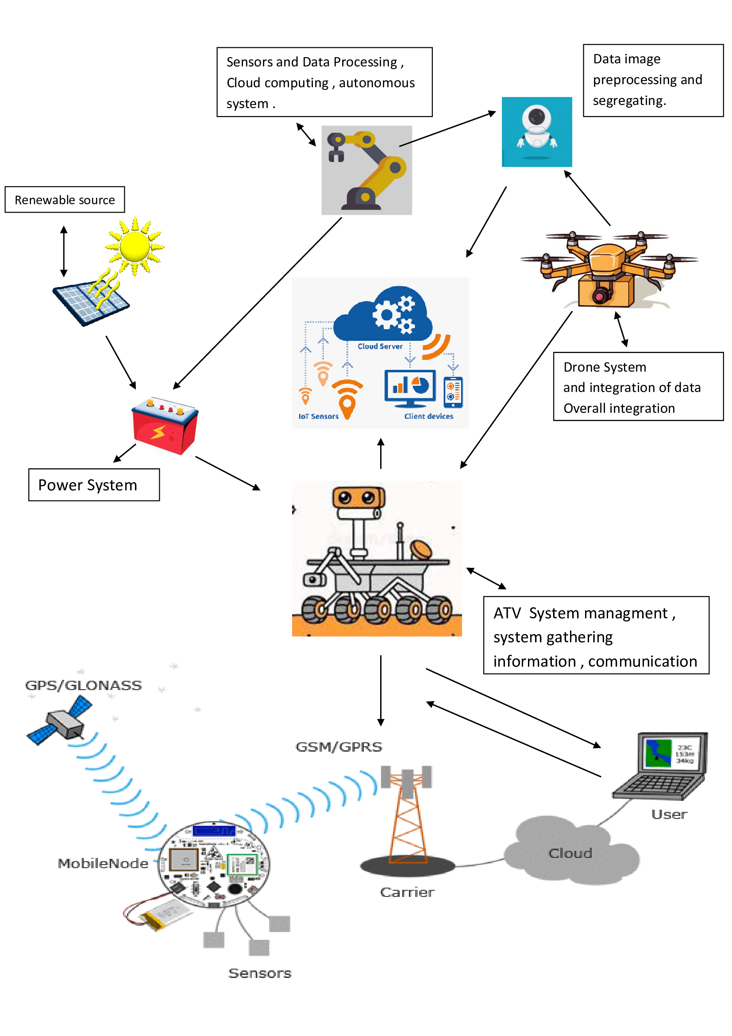

- What are the aspects of your disclosure that you want to claim/monopolize?
Proposed Claims:

Our Integrated Emergency Vehicle System revolutionizes disaster response by combining cutting-edge technologies into a single, versatile platform. A sleek drone landing pad is seamlessly integrated into the vehicle's structure, allowing for secure takeoff and landing in various weather conditions. The vehicle also features robotic arms capable of performing a range of rescue operations, from lifting debris to handling injured individuals with delicate care. These arms boast a robust mechanical design, precise control systems, and specialized end effectors for different tasks. Advanced sensors provide force feedback, temperature sensing, and other vital environmental data. To further enhance operations, AI-powered algorithms assist in arm operation and task planning.

The drone system is a key component of our vehicle, with a focus on innovative deployment, control, and retrieval mechanisms. Operators can deploy drones from a moving vehicle and manage them from within, thanks to sophisticated control systems. A secure retrieval mechanism enables drones to safely return and dock with the vehicle, even while it's in motion. Wireless charging capabilities keep drones and other equipment powered and ready for action. A comprehensive camera surveillance system provides situational awareness, while an adjustable platform keeps health supplies organized and easily accessible. This synergy of components creates a mobile emergency response unit that's more than the sum of its parts, offering unprecedented versatility and efficiency in disaster scenarios.

- Have you conducted novelty/inventiveness search for your invention? If yes, what are the databases /references used by you? What are the search results?

- IEEE Xplore
- ScienceDirect
- Google Scholar
- Google Patents
We Used these papers to search for inventiveness and this particular project is not made by anyone till now. The search results were positive.

- Do you feel that a person of “average” skill (not-extraordinary skill) in your area of technology would have arrived at your invention with existing knowledge in public domain? If no, what could be the reasons for the same?

No, the person with average skill may not create this inventive design as it requires basic and advanced skill and knowledge to design an automobile cabin cooling system.

11. Kindly provide broad workable ranges for all the parameters involved in your invention.

The vehicle's drone pad, 1-2 meters in diameter, is made of lightweight materials and can hold 5-10 kg. It has 1-2 robotic arms with a reach of 1-2 meters and can carry 5-20 kg. The health supply platform is 1x1 to 2x2 meters, adjusting vertically from 0.5 to 1 meter. Camera surveillance includes fixed, and thermal types, with HD to Full HD resolution. Equipped with a 10-20 watt wireless charger .It has RGB, thermal, and infrared camera modules, 5-12 MP, and 4-6 modules. The Arduino system, using Mega Due and Nvidia Jetson, supports sensors like distance, temperature, and GPS. It has a 5-10 km range on a single charge, handling rough and urban terrain. Ground-penetrating radars reach up to 10 meters, with a frequency range of 100 MHz to 1 GHz, and a resolution of 0.1-0.5 meters. Acoustic systems cover 20 Hz to 20 kHz, detecting up to 50 meters.

- References (if any) - N/A

- Inventors Details (Full Names, Nationality and Addresses)

Soutik Mandal , Indian , VIT Chennai
Rachana Datta , Indian , VIT Chennai
Sattwik Ghatak, Indian , VIT Chennai
Tathaghat Chakraborty, Indian , VIT Chennai

Mentor – Dr Sri Ramalakshmi

- Applicant Details (Full Names, Nationality and Addresses)

Soutik Mandal , Indian , VIT Chennai
Rachana Datta , Indian , VIT Chennai
Sattwik Ghatak, Indian , VIT Chennai
Tathaghat Chakraborty, Indian , VIT Chennai

Mentor – Dr Sri Ramalakshmi

Indian ,Vellore institute of Technology, Chennai

- Any additional notes or remarks. N/A

- Value addition in commercial (financial) aspects of your proposal

Integrating drone deployment, robotic arms, an adjustable health supply platform, and camera surveillance into a single vehicle significantly enhances operational efficiency and emergency response times, potentially reducing costs. This advanced vehicle is capable of handling various emergencies, from medical supply delivery to drone-assisted rescue operations, making it highly appealing to emergency services, disaster relief organizations, and government agencies. Featuring cutting edge technology like wireless charging and high-tech cameras, it attracts technical markets and stands out as a pioneering solution in emergency and disaster management. Its modular design allows for customization to meet diverse operational needs, increasing its market reach and scalability. Drone integration and robotic arm designs strengthen its intellectual property portfolio, offering a competitive edge. Although the initial investment is significant, the vehicle promises long-term cost savings through optimized resource deployment and improved emergency management. Additionally, partnerships with technology providers and governmental bodies can facilitate market expansion, leveraging expertise and distribution channels for greater commercial success

- Which industry can use your invention?

Health care industries , Military fields , NDRF(national disaster rescue force )

